Laboratoriya ishi №7

Mavzu: CSS orqali matn va bloklarni bezash

Fan: Web ilovalar

Maqsad: Veb sahifalarda matn elementlari (sarlavha, paragraf, havola) va blok elementlarini (div, section) CSS yordamida turlicha bezash, ularni vizual jihatdan chiroyli ko‘rinishga keltirish.

1. Nazariy qism
CSS (Cascading Style Sheets) — bu veb sahifalarning tashqi ko‘rinishini bezatish uchun ishlatiladigan uslub tili. CSS yordamida matn, fon, ramka, soyalar, o‘lchamlar va joylashuvlarni o‘zgartirish mumkin.

CSS orqali bezashning asosiy usullari:
Matn bezagi:
*color — matn rangi
*font-size — shrift o‘lchami
*font-family — shrift turi
*text-align — matnni joylashtirish (chap, o‘rta, o‘ng)
*text-transform — katta-kichik harflarni boshqarish
*text-shadow — matnga soyalar qo‘shish
Blok bezagi:
*background-color — fon rangi
*border — ramka
*border-radius — burchaklarni yumaloqlash
*box-shadow — blok soyasi
*margin, padding — ichki va tashqi oraliqlar

2. Amaliy qism

Fayl tuzilmasi:
/lab7/
│
├── index.html
└── style.css

index.html
<!DOCTYPE html><html lang="uz"><head>
<meta charset="UTF-8">
<meta name="viewport" content="width=device-width, initial-scale=1.0">
<title>CSS orqali matn va bloklarni bezash</title>
<link rel="stylesheet" href="style.css"></head><body>
<header>
<h1>CSS orqali matn va bloklarni bezash</h1>
</header>

<section class="intro">
<p>
Ushbu sahifada <b>CSS</b> texnologiyasi yordamida matn va blok elementlarini bezash usullarini ko‘rib chiqamiz.
</p>
<a href="#" class="link">Ko‘proq o‘qish →</a>
</section>

<section class="bloklar">
<div class="blok birinchi">
<h2>1-blok</h2>
<p>Oddiy fon va soyali matn namunasi.</p>
</div>

<div class="blok ikkinchi">
<h2>2-blok</h2>
<p>Gradient fon va radiusli chekkalar bilan.</p>
</div>

<div class="blok uchinchi">
<h2>3-blok</h2>
<p>Hover effekti bilan o‘zgaradigan blok.</p>
</div>
</section>

<footer>
<p>&copy; 2025. Web ilovalar fanidan laboratoriya ishi.</p>
</footer></body></html>

style.css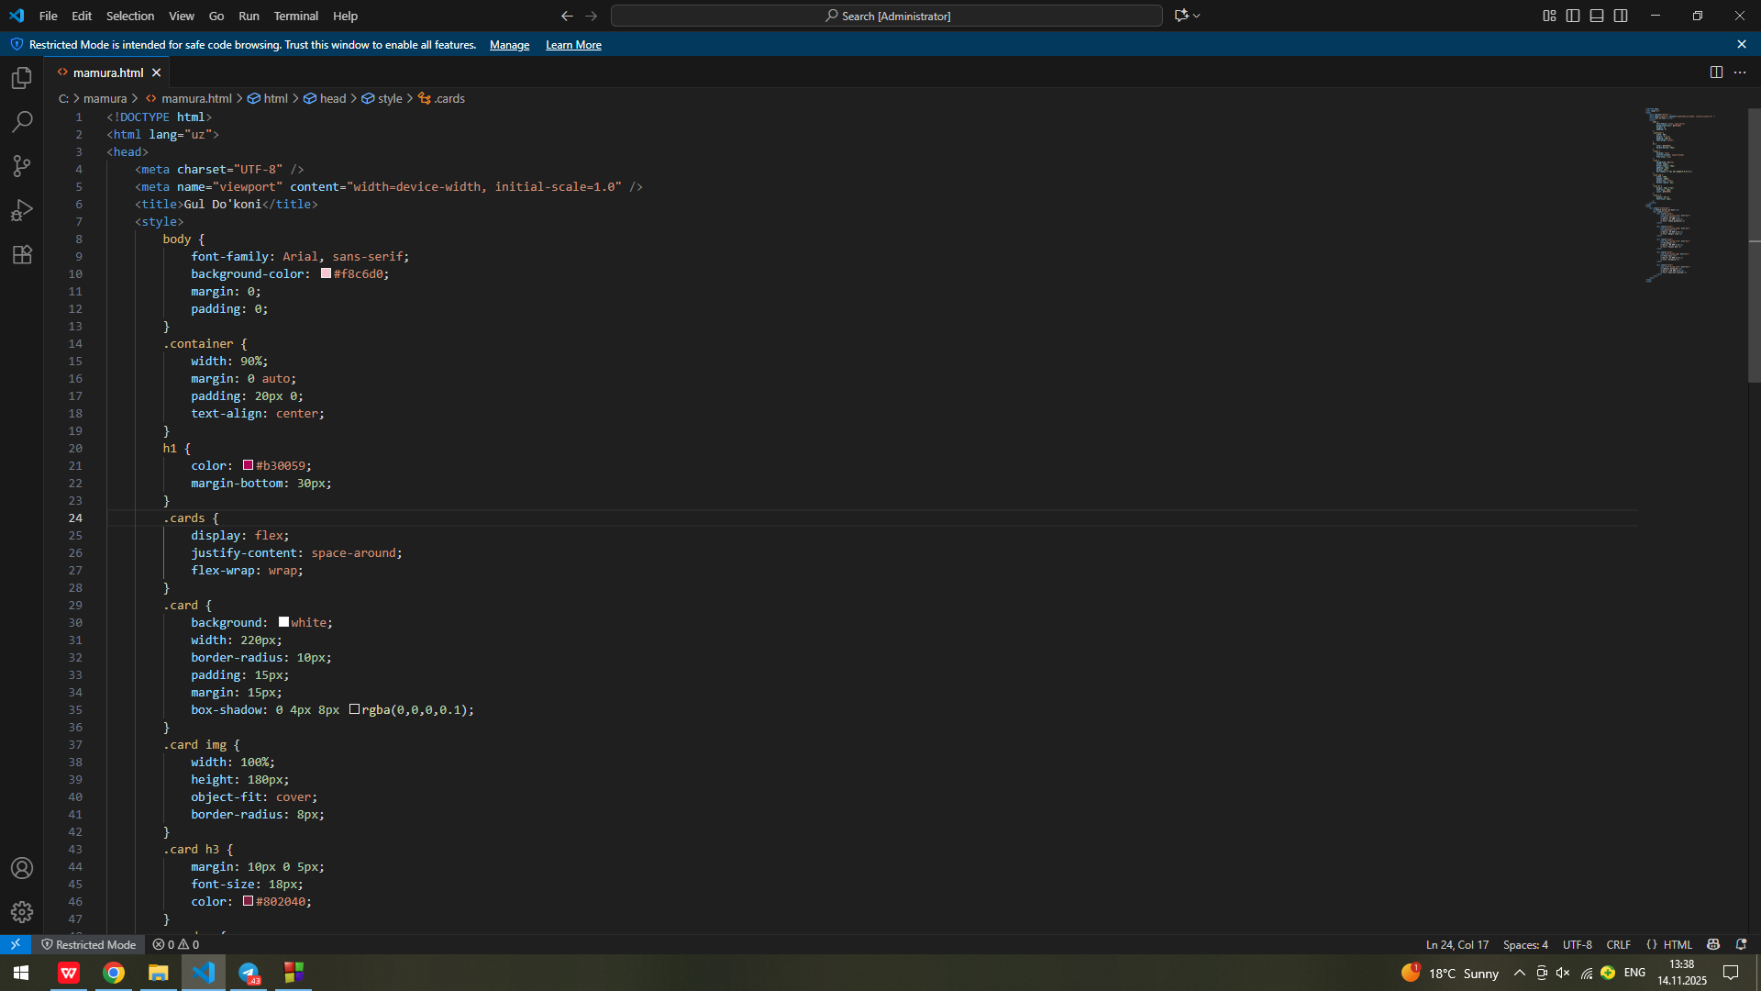

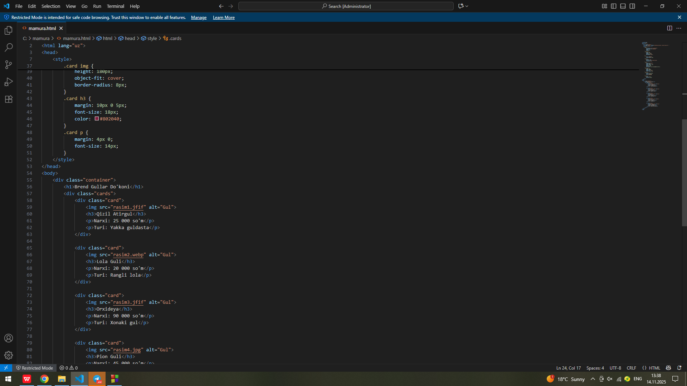

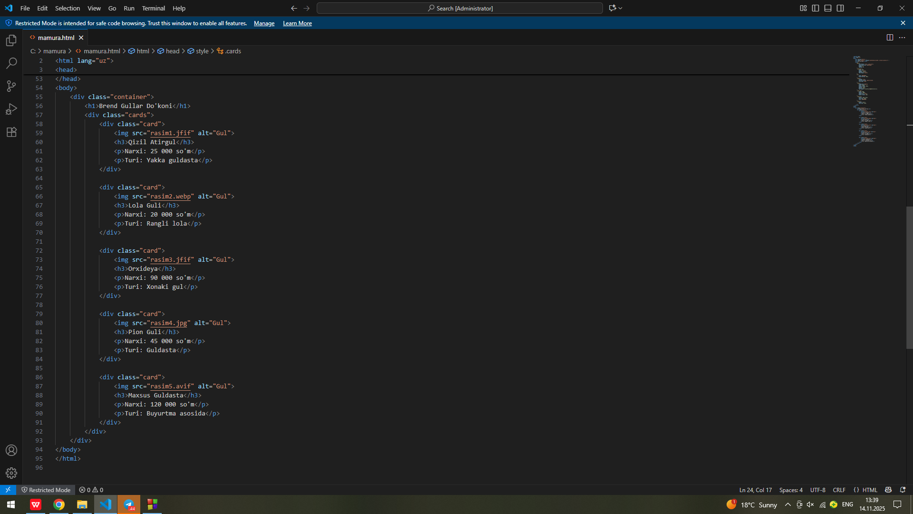

3. Natija
*Brauzerda sahifa ochilganda quyidagilar kuzatiladi:
*Sarlavha rangli fon bilan chiqadi.
*Matn markazda joylashgan.
*Uchta blok element turlicha bezatilgan (fon, soya, radius, hover effekti bilan).
*Hover (sichqoncha olib borilganda) effektlar ishlaydi.
Topshiriq:Gul do’konining sayti

<!<!DOCTYPE html>
<html lang="uz">
<head>
<meta charset="UTF-8" />
<meta name="viewport" content="width=device-width, initial-scale=1.0" />
<title>Gul Do'koni</title>
<style>
body {
font-family: Arial, sans-serif;
background-color: #f8c6d0;
margin: 0;
padding: 0;
}
.container {
width: 90%;
margin: 0 auto;
padding: 20px 0;
text-align: center;
}
h1 {
color: #b30059;
margin-bottom: 30px;
}
.cards {
display: flex;
justify-content: space-around;
flex-wrap: wrap;
}
.card {
background: white;
width: 220px;
border-radius: 10px;
padding: 15px;
margin: 15px;
box-shadow: 0 4px 8px rgba(0,0,0,0.1);
}
.card img {
width: 100%;
height: 180px;
object-fit: cover;
border-radius: 8px;
}
.card h3 {
margin: 10px 0 5px;
font-size: 18px;
color: #802040;
}
.card p {
margin: 4px 0;
font-size: 14px;
}
</style>
</head>
<body>
<div class="container">
<h1>Brend Gullar Do'koni</h1>
<div class="cards">
<div class="card">
<img src="rasim1.jfif" alt="Gul">
<h3>Qizil Atirgul</h3>
<p>Narxi: 25 000 so'm</p>
<p>Turi: Yakka guldasta</p>
</div>

<div class="card">
<img src="rasim2.webp" alt="Gul">
<h3>Lola Guli</h3>
<p>Narxi: 20 000 so'm</p>
<p>Turi: Rangli lola</p>
</div>

<div class="card">
<img src="rasim3.jfif" alt="Gul">
<h3>Orxideya</h3>
<p>Narxi: 90 000 so'm</p>
<p>Turi: Xonaki gul</p>
</div>

<div class="card">
<img src="rasim4.jpg" alt="Gul">
<h3>Pion Guli</h3>
<p>Narxi: 45 000 so'm</p>
<p>Turi: Guldasta</p>
</div>

<div class="card">
<img src="rasim5.avif" alt="Gul">
<h3>Maxsus Guldasta</h3>
<p>Narxi: 120 000 so'm</p>
<p>Turi: Buyurtma asosida</p>
</div>
</div>
</div>
</body>
</html>

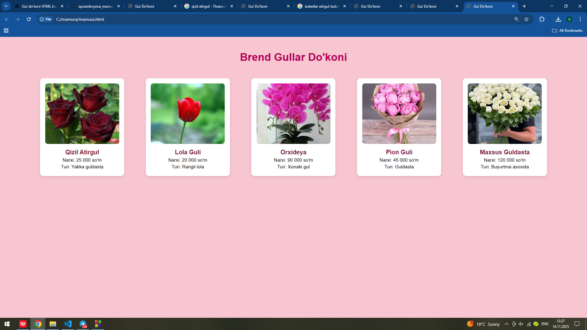

4. Xulosa
Ushbu laboratoriya ishida CSS yordamida matn va blok elementlarini bezash usullari amalda qo‘llandi.
Natijada, foydalanuvchiga estetik jihatdan yoqimli va qulay interfeys yaratish imkoniyati hosil bo‘ldi. CSS web-sahifani dizaynerlik jihatidan boyitadi va struktura (HTML) bilan uslub (CSS)ni ajratishga yordam beradi.

